Despite the challenges of the past year, TGW Logistics is investing 140 million euros in its Marchtrenk location

- The Upper Austrian technology company raised its revenue
by 3.5 percent to 955.8 million euros
- Investment in the expansion of the Marchtrenk headquarters, research & development, and the employees
- TGW Logistics is among the top 10 internationally leading intralogistics specialists

(Marchtrenk, Austria, 20 October 2023) TGW Logistics has completed its 2022/2023 business year (1 July 2022 to 30 June 2023). The internationally active technology company, which plans and realises logistics centres and supports them during live operation, was able to increase its revenue to 955.8 million euros despite the prevailing challenging circumstances. The number of employees rose to 4,382.

Looking back on the past months, Chief Executive Officer Harald Schröpf highlights that:

"TGW Logistics' revenue increased by 3.5 percent to 955.8 million euros and our order intake amounts to approximately one billion euros. Like many other companies, we faced great challenges due to massive cost increases in our international projects and to deteriorated supply chains."

In the industries of fashion & textile, grocery and industrial & consumer goods, local and international companies alike trust in the intralogistics expertise of the Austrian company. During the 2022/23 business year, such companies as the leading sporting goods retailer INTERSPORT Austria, Sweden's number 1 grocery retailer ICA, and the online grocery specialist Picnic all contracted TGW Logistics to automate their processes.

Slowed processes due to the growth of recent years

TGW Logistics has grown significantly in recent years, expanding its competencies and securing a spot among the top 10 international intralogistics specialists. However, this growth has also slowed down processes in some areas; therefore, the technology company has kicked off a transformation programme that is meant to test structures, increase speed and make the company fit for the future.

20 percent more for research & development

The budget for research and development is 47.7 million euros, an increase of roughly 20 percent from last year. Particular focus will be placed on robotics, artificial intelligence and digitalisation. Alongside a new research & development structure, the technology company is also investing more heavily in strategic partnerships such as its collaboration with SAFELOG in the area of mobile robots.

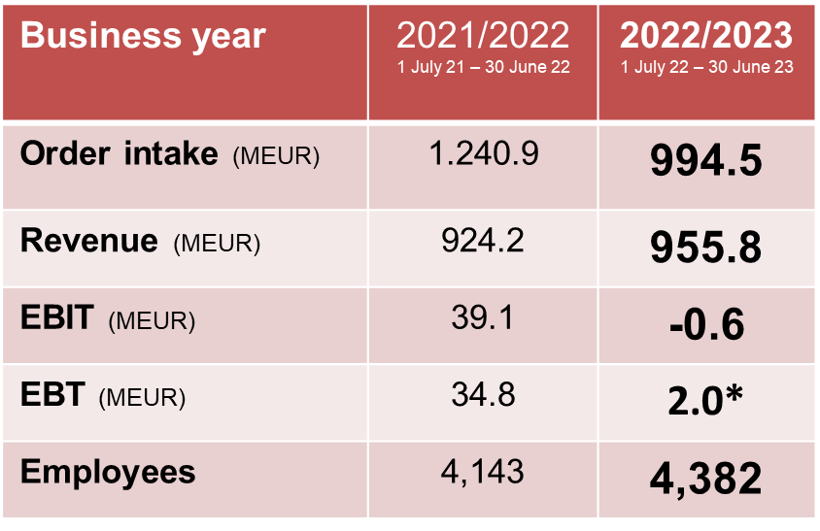

140 million euros for the Upper Austrian location

Starting in the summer of 2024, TGW Logistics will be expanding its international headquarters in Marchtrenk, adding new offices as well as production and storage areas. With this 140-million-euro investment, the intralogistics specialist is laying the foundation for growth in the coming years. Moreover, this expansion is a clear affirmation of the Upper Austrian location and the commitment to the continued successful development of TGW Logistics.

Harald Schröpf is stepping down from his CEO function

Harald Schröpf has decided to step down from his function as Chief Executive Officer of TGW Logistics during the 2024 calendar year. He will remain in this position until the handover to an as-yet undetermined successor. Harald Schröpf stresses that:

"This was anything but an easy decision for me because I care deeply about TGW Logistics, our employees and our customers. Yet this step has been in the works for some time. Two years have already passed since I informed our owner, the TGW Future Private Foundation, of my desire to turn a new page and dedicate more time to my family and private interests. The Foundation and I are convinced that this change will give rise to a new dynamic and fresh motivation to continue to pursue and nurture the successful development that we have enjoyed these past years."

Under Harald Schröpf's leadership, the revenue of TGW Logistics increased from 621 to 955 million euros and the number of employees rose from 2,776 to more than 4,400.

www.tgw-group.com
About TGW Logistics:
TGW Logistics is one of the leading international suppliers of material handling solutions. For over 50 years, the Austrian specialist has implemented highly automated systems for customers, including brands from A as in Adidas to Z as in Zalando. As systems integrator, TGW plans, produces, implements and services complex logistics centres – from mechatronic products and robots to control systems and software.

TGW Logistics has subsidiaries in Europe, China and the US and employs more than 4,400 people worldwide. In the 2022/23 business year, the company generated a total turnover of 955 million euros.

Pictures:
Reprint with reference to TGW Logistics free of charge. Reprint is not permitted for promotional purposes.

Contact:
TGW Logistics Group GmbH
A-4614 Marchtrenk, Ludwig Szinicz Straße 3
T: +43.50.486-0
F: +43.50.486-31
e-mail: tgw@tgw-group.com

Press contact:
Alexander Tahedl
Communications Specialist
T: +43.50.486-2267
M: +43.664.88459713
alexander.tahedl@tgw-group.com

